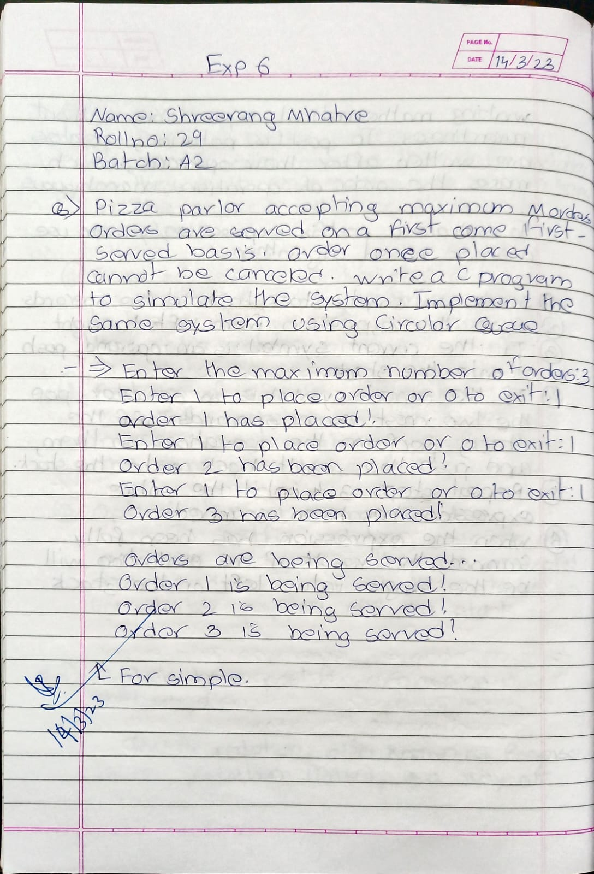

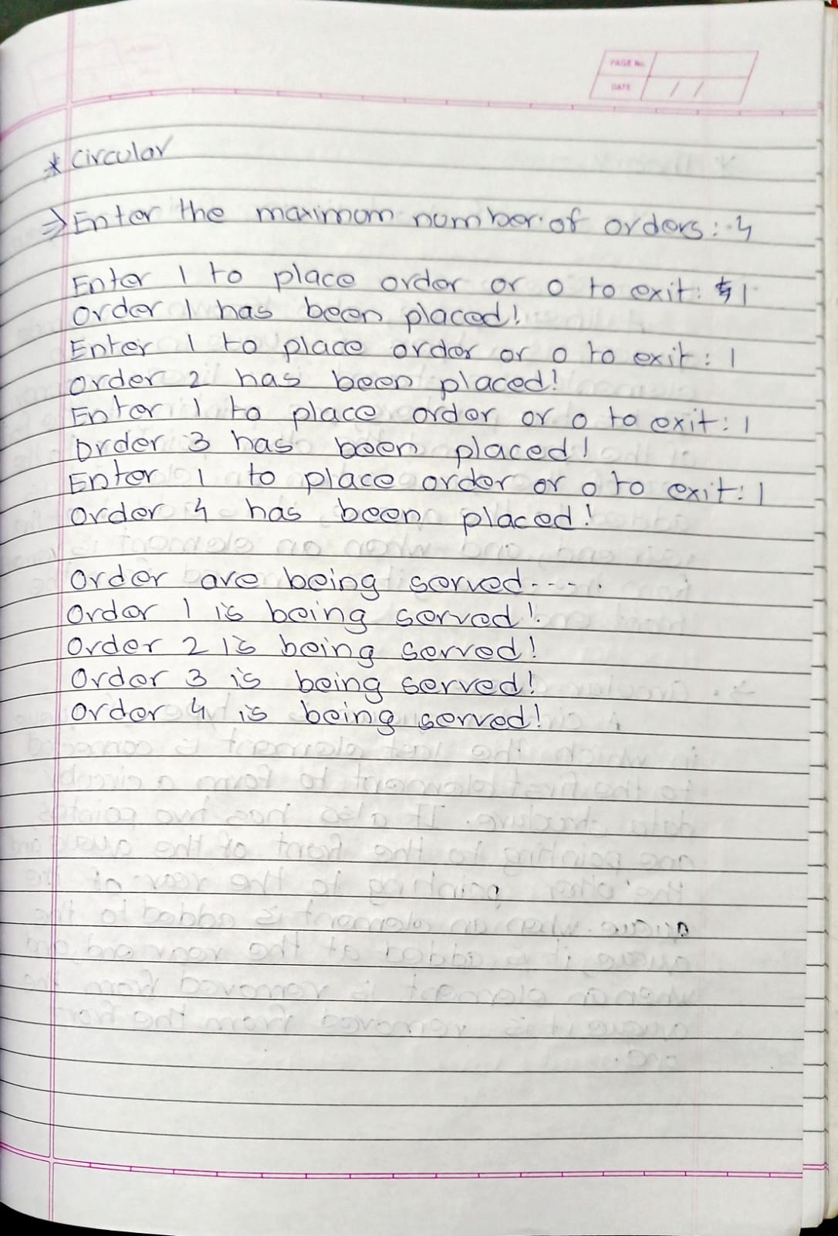

**Simple:**

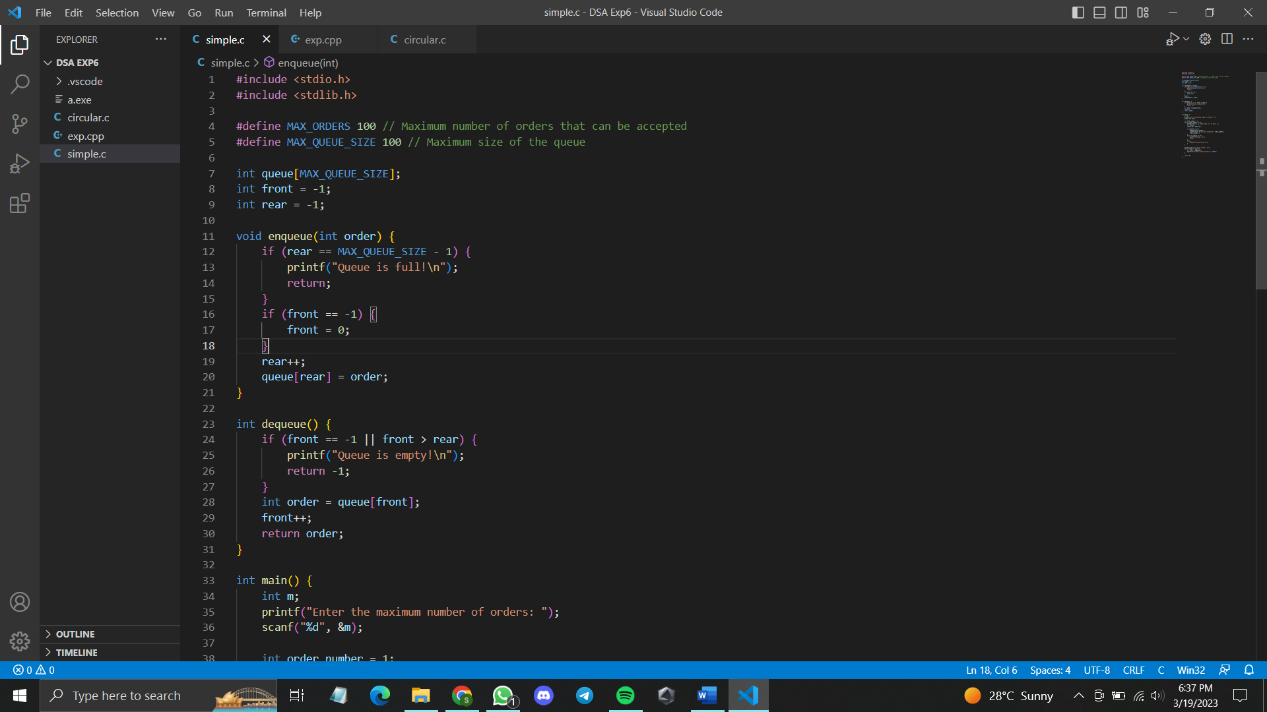

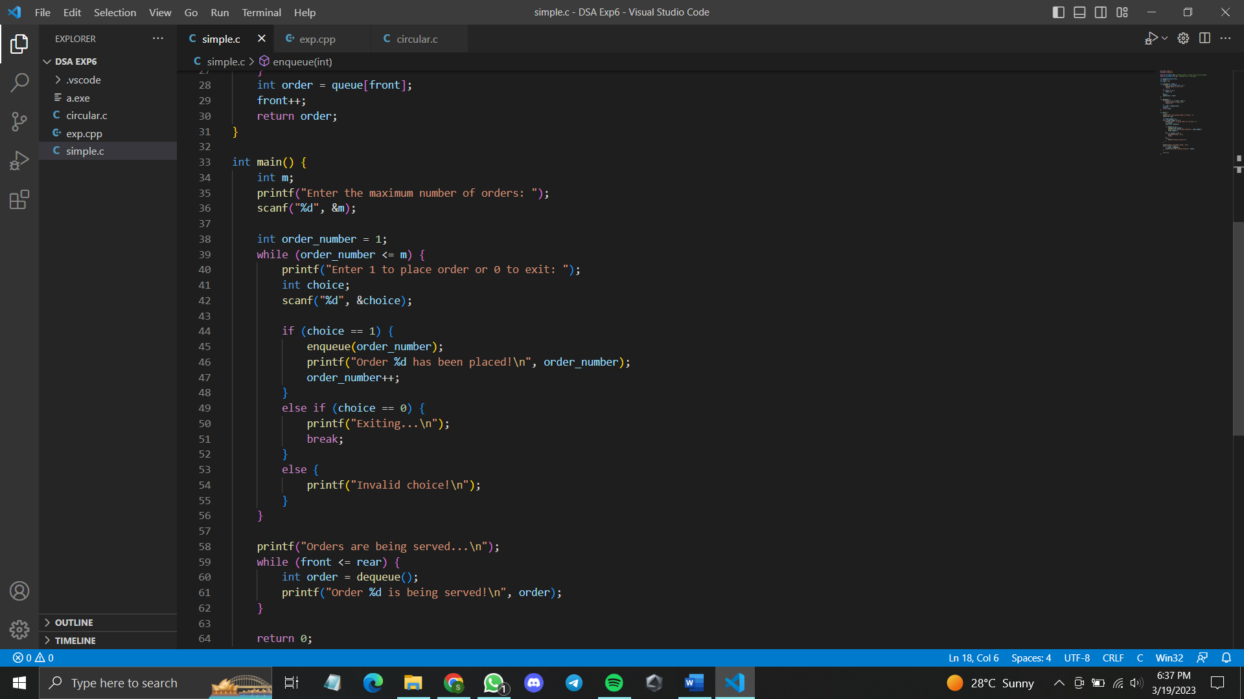

**Simple code:**

#include <stdio.h>

#include <stdlib.h>

#define MAX_ORDERS 100 // Maximum number of orders that can be accepted

#define MAX_QUEUE_SIZE 100 // Maximum size of the queue

int queue[MAX_QUEUE_SIZE];

int front = -1;

int rear = -1;

void enqueue(int order) {

if (rear == MAX_QUEUE_SIZE - 1) {

printf("Queue is full!\n");

return;

}

if (front == -1) {

front = 0;

}

rear++;

queue[rear] = order;

}

int dequeue() {

if (front == -1 || front > rear) {

printf("Queue is empty!\n");

return -1;

}

int order = queue[front];

front++;

return order;

}

int main() {

int m;

printf("Enter the maximum number of orders: ");

scanf("%d", &m);

int order_number = 1;

while (order_number <= m) {

printf("Enter 1 to place order or 0 to exit: ");

int choice;

scanf("%d", &choice);

if (choice == 1) {

enqueue(order_number);

printf("Order %d has been placed!\n", order_number);

order_number++;

}

else if (choice == 0) {

printf("Exiting...\n");

break;

}

else {

printf("Invalid choice!\n");

}

}

printf("Orders are being served...\n");

while (front <= rear) {

int order = dequeue();

printf("Order %d is being served!\n", order);

}

return 0;

}

**Circular**

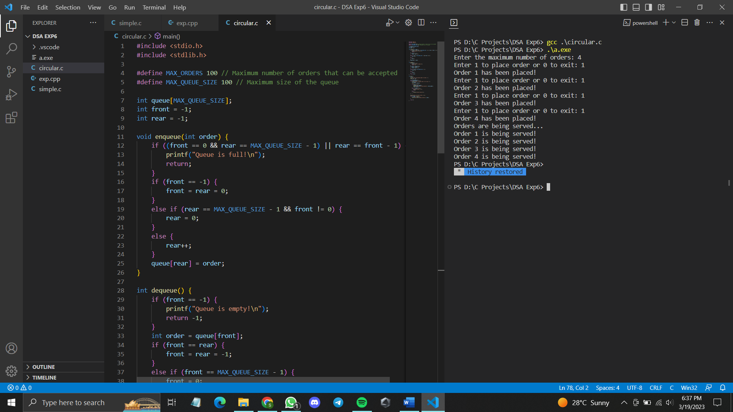

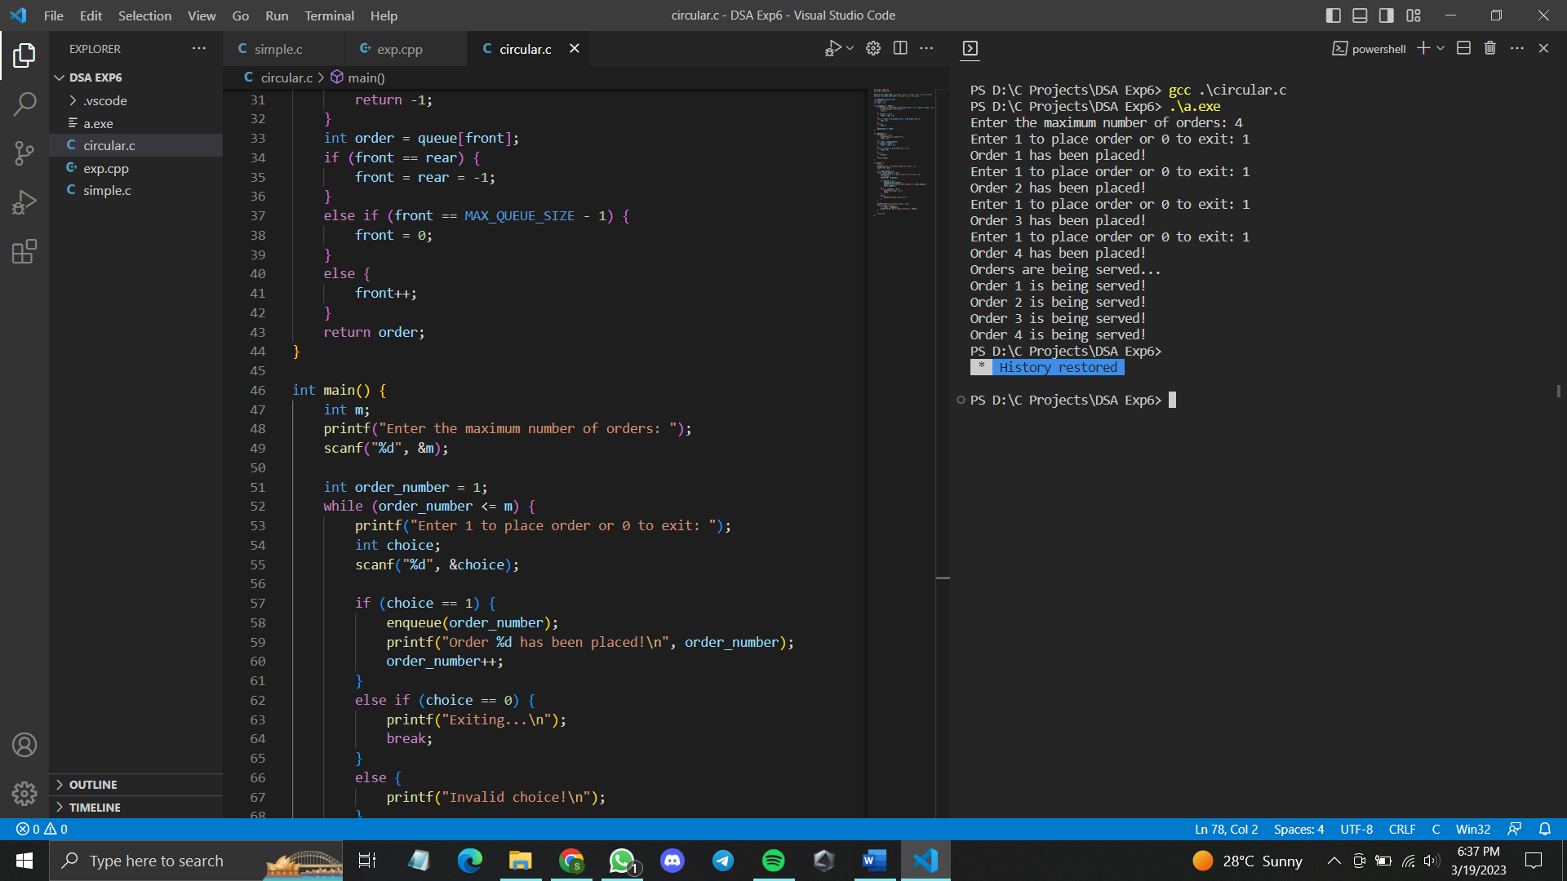

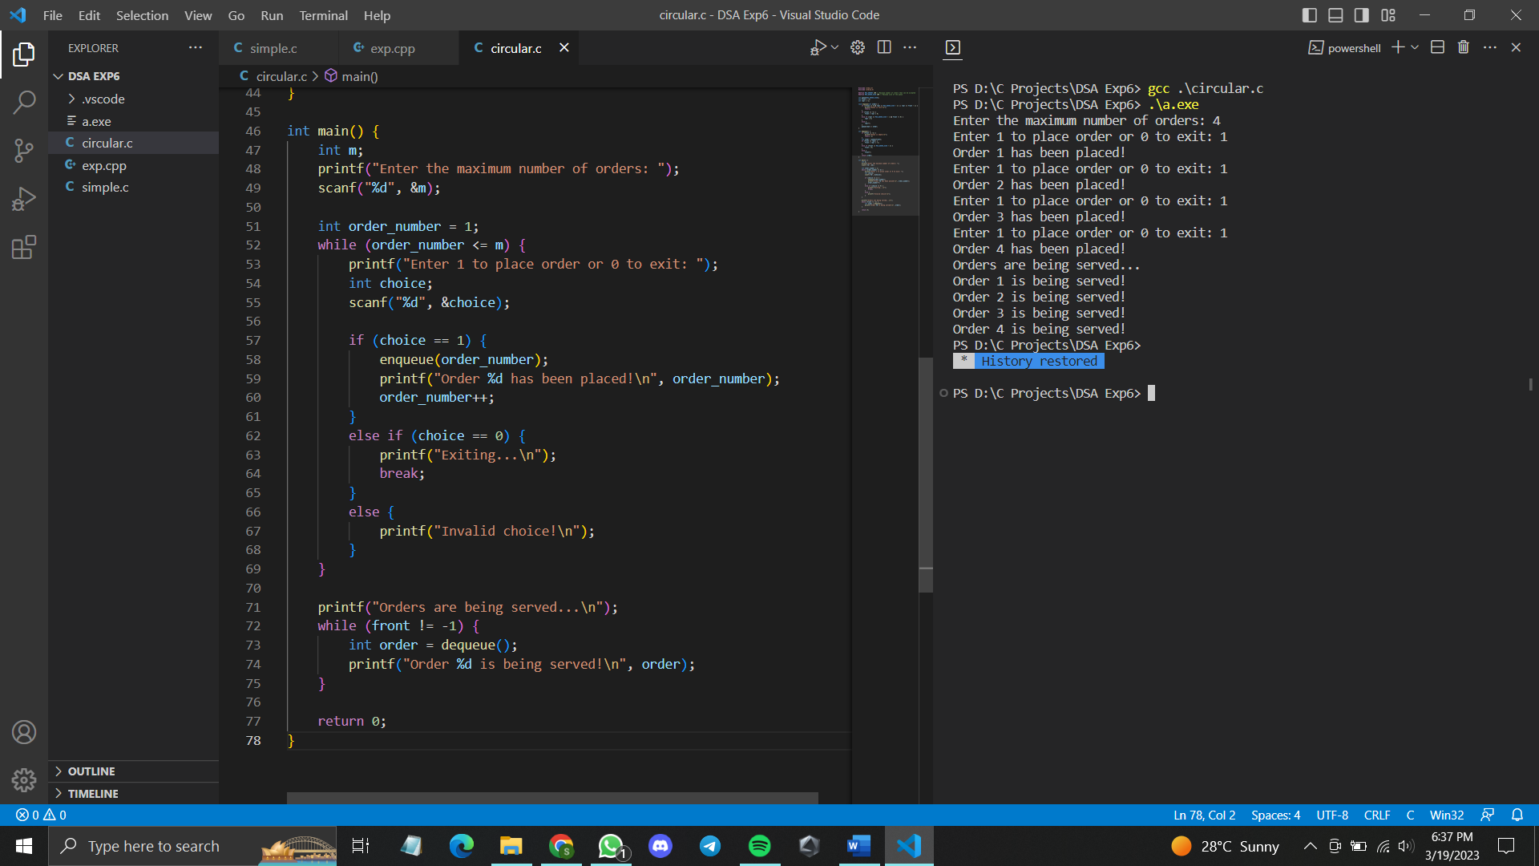

**Circular code:**

#include <stdio.h>

#include <stdlib.h>

#define MAX_ORDERS 100 // Maximum number of orders that can be accepted

#define MAX_QUEUE_SIZE 100 // Maximum size of the queue

int queue[MAX_QUEUE_SIZE];

int front = -1;

int rear = -1;

void enqueue(int order) {

if ((front == 0 && rear == MAX_QUEUE_SIZE - 1) || rear == front - 1) {

printf("Queue is full!\n");

return;

}

if (front == -1) {

front = rear = 0;

}

else if (rear == MAX_QUEUE_SIZE - 1 && front != 0) {

rear = 0;

}

else {

rear++;

}

queue[rear] = order;

}

int dequeue() {

if (front == -1) {

printf("Queue is empty!\n");

return -1;

}

int order = queue[front];

if (front == rear) {

front = rear = -1;

}

else if (front == MAX_QUEUE_SIZE - 1) {

front = 0;

}

else {

front++;

}

return order;

}

int main() {

int m;

printf("Enter the maximum number of orders: ");

scanf("%d", &m);

int order_number = 1;

while (order_number <= m) {

printf("Enter 1 to place order or 0 to exit: ");

int choice;

scanf("%d", &choice);

if (choice == 1) {

enqueue(order_number);

printf("Order %d has been placed!\n", order_number);

order_number++;

}

else if (choice == 0) {

printf("Exiting...\n");

break;

}

else {

printf("Invalid choice!\n");

}

}

printf("Orders are being served...\n");

while (front != -1) {

int order = dequeue();

printf("Order %d is being served!\n", order);

}

return 0;

}

